* Why array index starts from index zero?

→ In most programming language, the name of any array is a pointer, which is nothing but a reference to a memory location, and so the expression array[n] points to a memory location which is n-elements away from the first element. This means that the index is used as an offset. The first element of the array is exactly contained in the memory location that array points to (0 elements away), so it should always be referred as array[0].

تشير الاري الي مكان الموجود في ال ميموري – فالميموري غالبا تبدء من العنصر صفر و لذالك تبدء الاري من صفر أيضا ..

* The difference between the && --- and in php ?

→ They do the same thing, but && has higher precedence than AND

ANDالانها لها الاسبقية في التنفيذ عن &&

* pass by value and pass by reference?

## → Pass by Value - two variables are passed to swap () function. Even though swapping mechanism takes place inside the function it doesn't change values of variables that were passed.

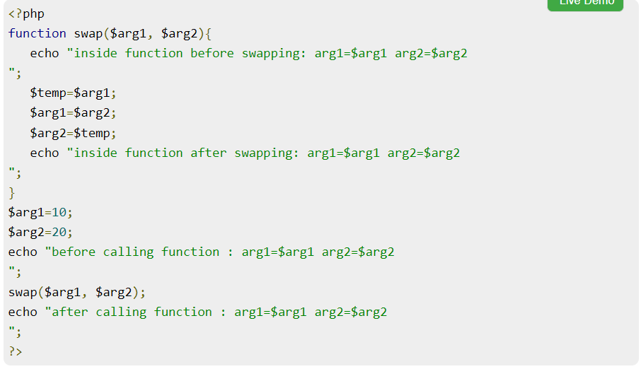

## Pass by reference.

In order to receive arguments by reference, variable used formal argument must be prefixed by & symbol. It makes reference to variables used for calling the function. Hence, result of swapping inside function will also be reflected in original variables that were passe

